EXECUTIVE SUMMARY
Madison Community Hospital, Inc. DBA Samaritan Behavioral Center was established in 2009. When the former Mercy Hospital closed in Detroit, the question of what would happen to the campus was a concern for the community it served. Samaritan Behavioral Center and St. John Health System reached an agreement that led to the establishment of an inpatient psychiatric and mental health services unit at the hub of the former campus, now called The Samaritan Center. Today the Samaritan Center building is a wellness centered community that meets the quality of life needs in Detroit’s eastside neighborhoods. The Samaritan Center has partnered with Samaritan Behavioral Center to offer vital psychiatric and mental health services 24 hours per day, 7 days per week to individuals and families during a time of crisis, and to help integrate those individuals back into the community and their everyday life routines.
Samaritan Behavioral Center is a 55-bed inpatient psychiatric hospital that aims to provide the highest standard of care through individualized, patient-centered treatment plans based on the unique needs of each patient in a safe and supportive environment. The Samaritan Behavioral Center sees over 850 inpatient admissions and discharges on an annual basis.
As a non-profit psychiatric hospital providing essential services that benefit Detroit and Wayne County communities, we continue to reinvest our resources back into the communities we serve. We do this through our expert and caring psychiatric and medical teams, and a multifaceted approach to mental health services strategically responsive to the community needs identified herein.

COMMITMENT TO COMMUNITY HEALTH
Purpose and Process for the Community Health Needs Assessment
At the Samaritan Behavioral Center, our vision is to be the trusted partner in psychiatric care, leading the community in quality care and mental health services. To be truly transformative for the communities we serve, it is imperative that as an organization, we listen to the voices of those we serve. The City of Detroit and Wayne County are diverse communities and populations with unique characteristics, challenges, needs, and strengths.
To achieve this vision, Samaritan Behavioral Center must build trusted relationships with our patients and community members and assure those we serve that their needs inform our practices, policies, and allocation of resources. Assessing and responding to the changing needs of our patients is vital to developing and maintaining trusted relationships as we work toward a common goal – to improve the behavioral health status and overall mental health of the community.
In healthcare we face a constant challenge to allocate our limited time and resources to treat those seeking our help. By committing to a canvasing process of assessing the needs of our communities, Samaritan Behavioral Center can ensure that our resources are spent on the services presenting the greatest opportunity for transforming the mental health of those entrusting us to serve them.
The purpose of the 2019-2022 CHNA was to:
- Evaluate health needs of the community and discern whether previously identified needs continue to be priority areas.
- Identify resources potentially available to address the significant health needs identified through the CHNA.
- Inform the development of Implementation Plans to address the identified health priorities.
Community health is at the forefront of Samaritan Behavioral Center’s priorities. Our CHNA process ensures that our hospital, in concert with the community, is making sustainable, measurable improvements in the mental health of the communities we serve. A key component to our CHNA process was the development of a hospital Community Health, Equities, and Wellness Team, a multidisciplinary healthcare and administrative team that assists in the development and implementation strategies for the Community Health Needs Assessment.
Key functions of the Community Health, Equities and Wellness Team include:
- Assessing community health needs by addressing financial and other barriers to accessing care and addressing social, behavioral, and environmental factors that influence health in the community.
- Prioritize the significant health needs of the community and identify resources potentially available to address the significant health needs of the community.
- Assess community health care disparities and healthcare equity.
The Community Health Needs Assessment is a collaborative process between Samaritan Behavioral Center and community partner organizations. These partner organizations assisted in gathering stakeholder input to determine the most pressing health and social needs facing the community we serve. Samaritan Behavior Center utilized both primary and secondary data sources as part of the CHNA process.
Primary data was gathered through meetings, interviews, and focus groups made up of essential community agencies and persons representing the broad interests of the communities we serve to collect information about the community’s priorities for health, wellness, and quality of life.
Secondary data sources utilized in this CHNA include publicly available local, state, and national data on demographics, socio-economic factors, health behaviors, access to mortality from a wide range of sources. The most recent data available were reviewed using The City of Detroit Health Department Community Health Assessment, Michigan Department of Health and Human Services Michigan Behavioral Risk Factor Surveillance System (Michigan BRFSS) 2019-2021, State of Michigan Labor and Economics MDOT/ALICE, and the Michigan Department of Community Health Division of Health Disparities Reduction and Minority Health.
Samaritan Behavioral Center Community Health Needs Assessment 2019-2021 has provided the framework and foundation on which to build measurable community health improvement. The CHNA summary findings and outcomes were reviewed by Samaritan Behavioral Center Leadership and Board members leading to strategic and implementation plan modifications to align strategy with identified needs. The 2019-2021 CHNA and strategic plan was approved by the Governing Board.

Retrospective Review of Samaritan Behavioral Center 2016-2019 CHNA
In 2016, Samaritan Behavioral Center conducted a Community Health Needs Assessment of the City of Detroit and Wayne counties. Below is a table that summarizes the previous CHNA goal/activity and measured outcomes/progress.
SHARED PRIORITY | GOAL/ACITIVITY | OUTCOME/PROGRESS
Ensure access to care for persons with mental illness and supportive care to maintain stability achieved during hospitalization once discharged back into the community. | Establish partial hospitalization program for residents of Detroit and Wayne counties | Samaritan Behavioral Center was unable to establish a partial outpatient program at its current location due to onset on the global COVID19 pandemic and building access restrictions. To ensure care and maintain stability, we continued to work closely and collaborate with local community health partners on the placement and ongoing treatment for patients discharged from our facility.
Access to affordable medication for patients upon discharge | Complete 340B application to expand share pricing to patients | Samaritan Behavioral Center pharmacy conducted a focused survey of patient’s priority need for medication at the time of discharge. Cost of medications was the primary concern by a substantial margin, second to ease of pick up at pharmacy. Samaritan Behavioral Center pharmacy department reinvests into the community by filling and offering free of charge all patient’s medication upon discharge.
Ensure patients are discharged to the community in the most progressive setting available | Partner with facilities and programs in Wayne County to decrease the number of patients discharged to shelters | Samaritan Behavioral Center continues to work closely and collaborate with local community mental health organizations for optimal patient placement based on the unique needs of each patient at the time of discharge.
Patient’s limited access and barriers to transportation | “Provide a Ride” program will provide taxi vouchers at time of discharge for patient who cannot obtain transportation | Due to the onset of a global COVID19 pandemic, Samaritan Behavioral Center chose to offer in-house transportation rather than taxi vouchers. In-house transportation was free of charge and without distance limitations.
Increase awareness for families in diagnosing and treatment of behavioral health issues | “Outreach and Education” program for visitors of the Samaritan Center to attend meetings to explain mental health diagnosis, treatment, and outcomes. | Prior to the COVID19 global pandemic, Samaritan Behavioral Center hosted several outreach and education meetings reviewing mental health in the community. Community mental health resources were made available during outreach meetings.
COMMUNITIES SERVED
Definition and Description of Communities Served
For purposes of this needs assessment, the Samaritan Behavioral Center service area is defined as the population of the City of Detroit and Wayne County. Below is a map of the communities where Samaritan Behavioral Center receives most of its inpatient volume.

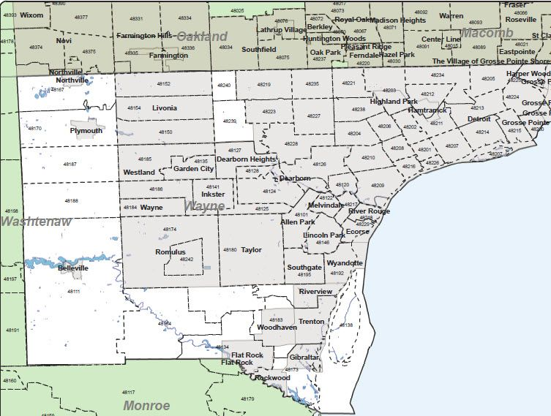

Although Samaritan Behavioral Center sees patients from outside the City of Detroit and Wayne County, most of the patient volume resides within this area. Therefore, the City of Detroit and Wayne County were chosen as the most appropriate geographical area for assessing and impacting community health needs and is the focus of the assessment.
The total 2021 estimated population in this area is as follows:
- City of Detroit – 651,802 residents
- Wayne County – 1,774,816 residents
The average household income for the City of Detroit and Wayne County is significantly less than surrounding geographic counties. Education is another area of need with 23% of residents having less than a high school diploma and only 14% having a bachelor’s degree or higher.
The racial makeup of Wayne County is quite different than the state, especially in Detroit, where racial and ethnic minorities comprise over 90% of the city’s population -78.8% African American, 7.6% Hispanic, and 3.6% Asian and Pacific Islander.
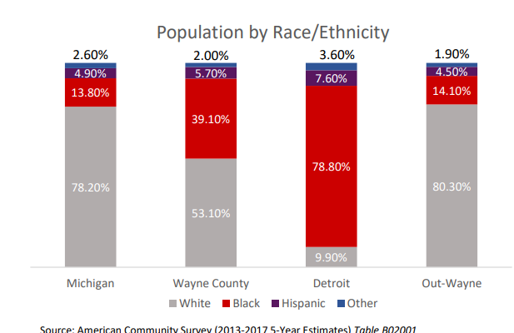

Demographics of Detroit/Wayne County
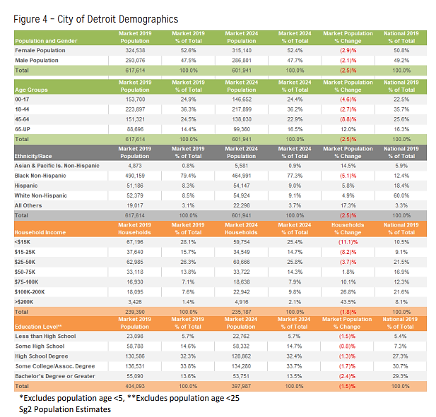
SOCIAL AND ENVIRONMENTAL HEALTH IN DETROIT AND WAYNE COUNTY
Health outcomes are not only determined by genetics and quality of healthcare received, but also by social determinants of health. Social determinants of health that have the greatest impact on the communities we serve are household income/poverty, housing, education level, transportation, and access to healthcare services.
Though the experiences of these individuals may vary, evidence suggests individuals in poverty face adverse health, economic, and educational outcomes. Many individuals also face barriers to increasing their incomes, especially those experiencing generational poverty.
As income and education decrease, the prevalence of risky health behaviors increases risky behaviors that result in poor physical and mental health outcomes.

According to the 2019-2022 Michigan Behavioral Risk Factor Survey:
- The City of Detroit 14.5% and Wayne County 13.7% report poor health on at least 14 days.
- The City of Detroit 17.7% and Wayne County 16.1% report poor mental health on at least 14 days.
The significance of poverty as a social and economic issue in Wayne County is a priority health need. The county’s poverty rates—regardless of age, race, or ethnicity—are much higher than state and national averages, with a total of 392,115 people living below the poverty line. Though the experiences of these individuals may vary, evidence suggests individuals in poverty face adverse health, economic, and educational outcomes. Many individuals also face barriers to increasing their incomes, especially those experiencing generational poverty.

Poverty in Wayne County
The federal poverty level provides a baseline for determining a community’s economic health, but the full extent to which poverty’s effects negatively impact communities and individuals requires a thorough understanding of local context. Also, once above the poverty level, individuals may still struggle to make ends meet depending on the local cost of housing, food, transportation, and medical care. Further exploring the types of poverty provides insight into this challenge.
It is estimated that 392,115 of a total 1.7 million residents in poverty within Wayne County earn less than the poverty threshold. This equates to an estimated 22.7% of Wayne County’s population living in poverty, which exceeds the national poverty level by 11.4 percentage points.
The average median household income for Wayne County is $52, 605 (state average: $63, 498) and households in poverty is 18% (state average: 13%). The labor force participation rate is 59% (state average: 61). An area of need within the community is the City of Detroit where the median household income is nearly 47% lower than the state average.
Across Wayne County, annual median incomes also differ by race.
- Black individuals’ income is significantly lower than all other races. In Wayne County, the median income is $29,380 and even lower in Detroit, at $26,958 for Black individuals.
- American Indian/Alaskan Native individuals’ income is even lower in Detroit, at $21,667.
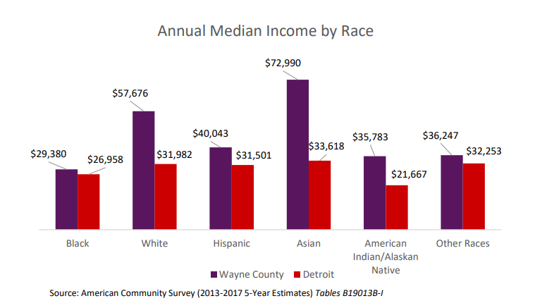
The financial concerns in Wayne County are complex and stem from a multitude of factors; the prevalence of ALICE households—those who are employed but still struggling to make ends meet—also indicates that employment alone is not always enough for financial stability.
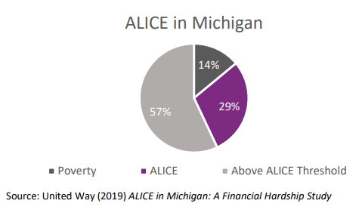
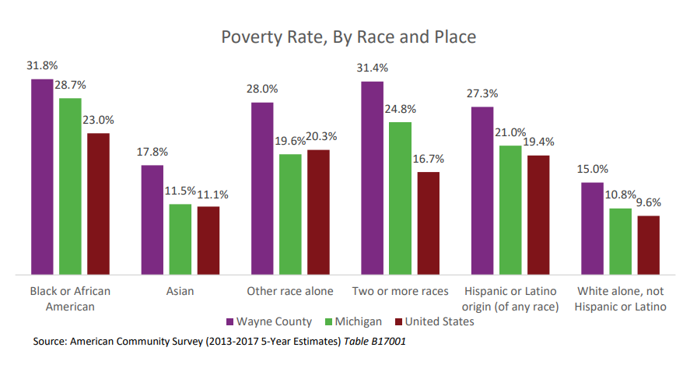

Transportation
Owning a vehicle is important for Wayne County workers. More than 80% of Wayne County workers drive to work alone, and another 9.3% carpool to work. Very few people in the county rely on public transportation to get to work (2.6%). Approximately 14% of Wayne County households and 25% of Detroit households do not own a vehicle.
- Black workers are more likely to use public transportation to travel to work (2.3%) than their White peers (0.7%). This higher rate may be due to a higher concentration of Black workers in the city of Detroit that have more access to public transportation.
- 98.6% of Wayne County residents travel an hour or less to get to work.
Housing and Homelessness
Adequate housing is an essential component to a thriving community, creating safe neighborhoods. Living in a thriving neighborhood increases an individuals’ chances of engaging in a healthier lifestyle and creates more opportunities for members of the community.
Evictions are another symptom of the housing crisis. Many factors contribute to eviction rates, including the increasing cost of housing and stagnant wages. Evictions can also increase homelessness and neighborhood stability rates.
- Michigan’s eviction rate is 5.74% on average, while the national average is 2.49%.
- Specifically in Detroit, eviction rates are 2.86% higher than the national average. There are almost 19 evictions per day in the city.
In Wayne County and Detroit, homelessness is estimated at approximately 8,351 individuals that reside in the community.
Education
Access to quality education is one of the most important components of a child’s life, impacting their opportunities through adulthood. Children who attend high-quality early childcare and education programs have higher test scores, fewer behavior problems and lower rates of grade repetition than their peers. As adults, they are more likely to pursue higher education, earn higher wages and rely less on government assistance programs.

Health
Wayne County ranks as Michigan’s least healthy county based on health behaviors, clinical care, social and economic, and physical environment factors. Factors that impact an individual’s wellbeing include both the environment in which they live as well as their health status. Individuals who are low-income or have a low level of educational attainment are specifically at risk for unhealthy behaviors and developing disease.

Health Insurance
Lack of health insurance coverage is a significant barrier to accessing needed healthcare. Additionally, insured children are likely to be healthier and have lower rates of avoidable hospitalizations and childhood mortality than their uninsured peers.
- 3.3% of youth (under 18) in Wayne County do not have health insurance. In Detroit, 3.9% of youth (under 18) do not have health insurance.
- 9.7% of Wayne County adults (18 and older) lack health insurance. In Detroit, 13.7% of adults (18 and older) lack health insurance.
Uninsured children and adults are more likely to visit emergency rooms due to a lack of access to other providers.
Environmental Health
Air pollution is associated with decreased lung function, chronic bronchitis, and asthma. Wayne County’s average daily air pollution density is 12.8 micrograms per cubic meter. Counties in Michigan range in air pollution rates from 9.8 – 12.9 micrograms per cubic meter, with a median rate of 11.6 micrograms per cubic meter

Mental Health
When asked to think about their mental health over the previous month, including stress, depression, and problems with emotions, 13.4% of Michigan adults reported having “not good” mental health for at least 14 days. Reporting poor mental health was most common among those with less than a high school diploma and individuals with a household income of less than $20,000.
- Among individuals with less than a high school level education, 28.7% reported poor mental health for at least 14 days of the previous month.
- Overall, more women (15.3% of total population) reported poor mental health than males (11.4% of total population).
- Rates of reported poor mental health varies throughout ages. 18% of individuals that reported poor mental health are between the ages of 18-24.

Throughout the state, approximately 4.6% of the population report having a serious mental illness, and 18.3% report having any mental illness. Michigan adults are slightly more likely than the national average to have been depressed; 20.5% of Michigan adults have been told that they have a form of depression, compared with 19% of adults nationwide. Michigan’s suicide rate per 100,000 residents is 14.1, which also is slightly higher than the nationwide rate of 14.0.

- In 2017, there were 187 deaths by suicide in Wayne County.
- Michigan’s suicides rates have increased by over 30% since 1999.
- 3.9% of Michigan’s population reported having thoughts of suicide in 2017.
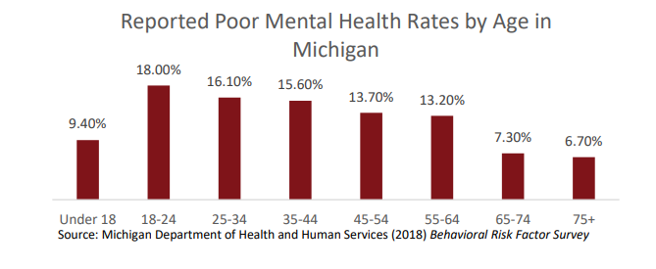

Substance Abuse
Substance abuse is another important facet of the mental healthcare system.
- According to the Michigan Behavioral Risk Factor Surveillance System (BRFSS) Survey, 57.52% of adults (18 and over) reported alcohol use in the past year, and 18.55% reported binge alcohol use in the past year.
- Individuals between the ages of 18-25 are more likely to have alcohol use disorder in Michigan.
- The top 5 substances utilized in Wayne County in FFY18 included heroin, alcohol, cocaine/crack, marijuana, and other opiates.
According to TEDS data, Wayne County saw a spike in heroin use in 2015. Although rates of use have been declining, nearly 2,000 individuals have been using heroin since 2011.
In 2017, there were 2,686 drug overdose deaths in Michigan, 12.1% higher than the previous year. Deaths from cocaine and synthetic opioids (tramadol, fentanyl) significantly increased, impacting the death rate for 2017.Opioids accounted for 76.4% of drug overdose deaths in 2017.
- In 2017, Wayne County experienced 1,780 drug overdose deaths, 20.9% increase from 2016.
- Wayne County ranks 25th out of all counties in the nation for drug overdose deaths, in 2012 it ranked 125th.

ASSESSMENT OF SIGNIFICANT HEALTH ISSUES IN WAYNE COUNTY/DETROIT
Based on the quantitative trends identified in the demographic and community health data, as well as qualitative information received from the community stakeholders, the areas of priority detailed below were identified for the community Samaritan Behavioral Center serves.
Samaritan Behavioral Center Community Health Assessment Goals:
- Mental Health Services/Suicide Prevention
- Housing and community placement services for discharged patients.
- Transportation
- Education

RECOMMENDATIONS FOR COMMUNITY HEALTH PRIORITIES
- Mental Health Services/Suicide Prevention
Samaritan Behavioral Center aims to protect and promote mental health and wellness and improve health access and outcomes by coordinating with other local community mental health and crisis intervention resources. Samaritan Behavioral Center will continue to collaborate with community mental health partners and strive to grow our community network of suicide intervention specialists to reduce the suicide rate of residents in the communities we serve.

- Housing and community placement services for discharged patients.
Samaritan Behavioral Center goal is to ensure basic housing needs and health of our patients are supported and sustained by increasing access to appropriate, available housing options and facility placement options by collaborating with local and regional community mental health departments and other local healthcare systems who provide mental health services in the community setting. Samaritan Behavioral Center social work services maintain strong relationships and work collaboratively with a multitude of community health plans and providers to support housing needs of the patients and communities we serve.

- Transportation
Samaritan Behavioral Center aims to improve health access and outcomes by strengthening access to the mental health services we provide and coordinate with community mental health outpatient resources by offering and arranging in-house transportation services. Our transportation services assist to reduce the health disparity of low-income community residents that live in a home that does not own a vehicle and therefore cannot access community mental health services. We provide our transportation free of charge to the patients we serve.

- Education
Samaritan Behavioral Center aims to improve mental health and wellness and overall quality of life in the communities we serve by strengthening education by coordinating community mental health and wellness resource events and learning opportunities. Samaritan Behavioral Center coordinates with the Samaritan Center building to provide community mental health resources flyers, educational hand-outs, and building posters that provide access to a multitude of community resources. Samaritan Behavioral Center will continue to build safe and supportive relationships with residents of the community through collaborative social networks and community partners.

